**Best Practices**

* For superior insights, the objectives of MMM and what it plans to achieve should be clearly set by:
  + Identifying drivers of revenue and quantifying impact
  + Optimizing spend across different marketing channels for maximum return
  + [Time-series forecasting](https://www.latentview.com/beginners-guide-to-forecasting/) for future plan of action
* Every touchpoint in the customer journey should be defined, tracked and measured for proper accounting of cost and revenue components by marketing levels such as geography, channel etc.
* Revenue regressed on cost or raw variables (clicks, impressions) by channel should be accounted and available at the same granular level (either through derivation or already set up by the company). It’s important to check key variables for both statistical and business significance
* Building an ‘S curve’ (sigmoid shape curve) to plot the growth rate of revenue as a function of cost will help determine the ‘Spend Limits.’ Appropriate ‘S Curve’ (logistic, gompertz, etc.) should be chosen based on the underlying distribution of the data to get accurate relationship between cost and revenue. ‘Optimal Point’ should be discovered where revenue growth rate is maximized for a given cost
* Test and control markets should be compared and then the feedback can be used to refine the model performance

Marketing-mix models decompose total sales into two components:

1. Base sales- factors like pricing, long-term trends, [seasonality](https://en.wikipedia.org/wiki/Seasonality), and also qualitative factors like [brand awareness](https://en.wikipedia.org/wiki/Brand_awareness) and [brand loyalty](https://en.wikipedia.org/wiki/Brand_loyalty).
2. Incremental sales- are the component of sales driven by marketing and promotional activities

Therefore, various non-linear transformations such as [Power, Negative Exponential](https://analyticsartist.wordpress.com/2015/03/08/advertising-diminishing-returns-saturation/), and [Hill](https://static.googleusercontent.com/media/research.google.com/en//pubs/archive/46001.pdf) were applied to media channels prior to modeling.

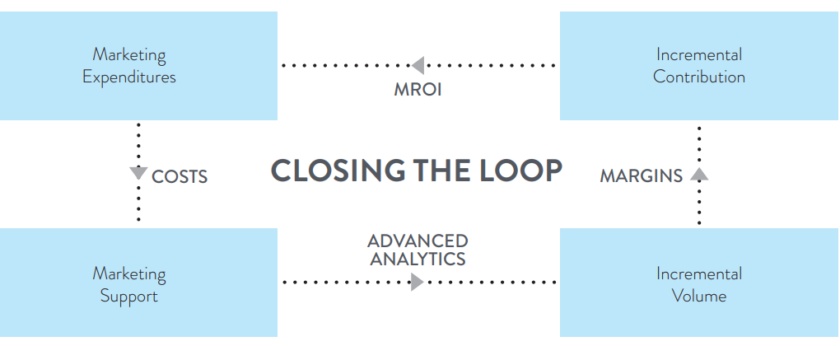

* overview of the key components and phases
* what to consider when incorporating your results into planning,

The four phases of a Marketing Mix Modeling project are:

1. Data collection and integrity: Collaborate with your Marketing Mix Modeling vendor to decide which data needs to be included.

2. Modeling: Test the models against your checklist. Ensure your in-house analytics team is involved.

3. Model-based business measures: Interpret the model-based outputs and look at your campaign’s effectiveness, efficiency and Marketing Return on Investment. Measure incrementality by campaign for all tactics so you can better understand drivers of incremental profit.

4. Optimization and simulation: Determine the best marketing mix for your next planning period.

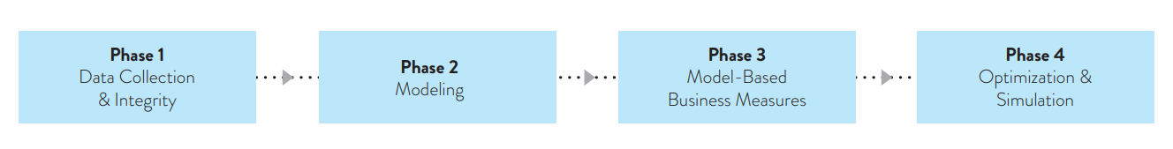

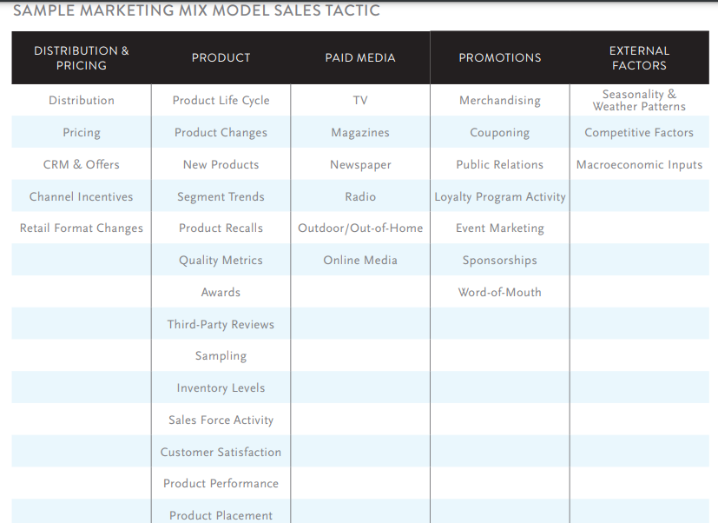

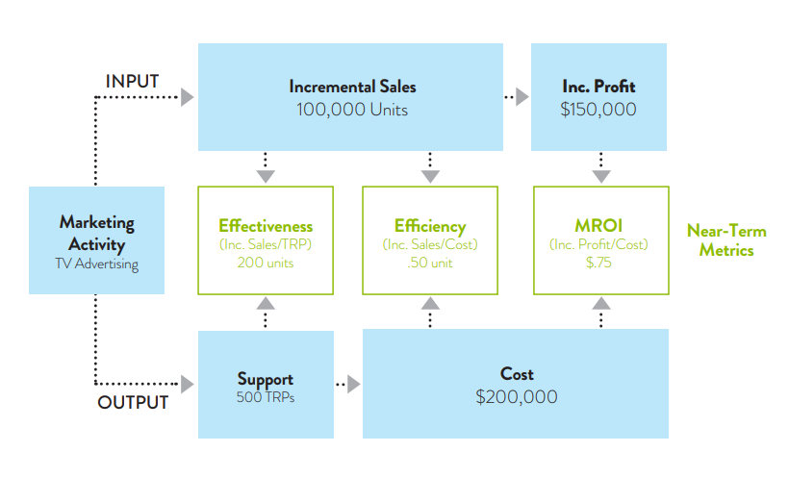

There are three approaches to measure how marketing targeted to a specific demographic segment can affect sales:

1. Advertiser Defined Segment Model: Aggregates the advertiser’s data to segments and model them.

2. Consumer Mix Model: Model store-level data where sales lift varies by trading area demos.

3. Hybrid Model: A two-phased modeling approach that uses storelevel and market-level data where lift varies by market demos.

While each model comes with statistical nuances, each can provide you with deep insights. For example, any of the three approaches can determine if a campaign has a “C-shape” or “S-shape” effect on sales, which is vitally important knowledge when planning media; these curves determine if it would be better for your campaign to follow a continuity or a flighting schedule.

Brand linkage tells you if your brand is being successfully linked to your ad campaigns, rather than forgotten about or being linked to your category in general. Brand linkage metrics generally increase with the continuity and intensity of a brand’s media investment, making flighting a poor option for improving brand linkage

*Brand Linkage proportional to continuity and Intensity of a brand media investment*

* A campaign with a C-shaped curve tells you that the first exposure had the largest impact on sales, and therefore you should go with advertising continuity.
* An S-shaped curve, on the other hand, illustrates the “threshold” effect, which means you should use flighting.

**Marginal Marketing Return on Investment** measures the financial impacts of the next $1 in media spend, making it more suitable for planning than Average Marketing Return on Investment, which is the metric best for financial reporting. Marginal Marketing Return on Investment is a key concept in conducting Optimizations and What-if exercises.

**Question for MMX (Checklist)**

Here are some key business questions to address for the MMX to begin with. Based on the questions we can line up the priorities and features, how will these questions be addressed? What data is/will be needed?

* BUDGET & FINANCIAL
  + What is the optimal marketing plan to maximize future net profits given our current budget, or a future tentative budget?
  + How should our future marketing budget be allocated among marketing tactics and campaigns?
  + Which geographies, channels, consumer segments, …have the largest lift and MROI? Which marketing tactics and campaigns have the best MROI?
* MARKETING & MEDIA
  + What is the most sales effective and efficient marketing tactic for a given demographic segment?
  + Are we able to drill deeper into MROI for a given Campaign? For example, are 15 second ads nearly as effective as 30 second ads?
  + What’s the difference in MROI for Network TV advertising and Cable TV advertising?
  + For a given campaign, is Continuity or Flighting better?
  + What was the year-over-year net change on sales from changes in the Marketing Mix?
  + How reliable and robust are effectiveness, efficiency and MROI for campaigns that begin at the end of the modeling window?
  + What’s the consumers’ media retention rate for each campaign?
  + Over how-long of time period do you measure MROI for a campaign?
  + How does our media performance compare to other advertisers in similar verticals?
  + Is my traditional media driving consumer generated media, which drives sales?
  + Are there synergies across media?
  + How should we prioritize media insights?
* PRICING
  + How is my advertising affecting consumer price sensitivity?
  + How does price sensitivity compare across products, segments and geographies?
  + What is the impact of a price change on sales and profits?
  + How does changing price impact volume?
* COMPETITIVE
  + Which competitor’s advertising campaigns are having the largest negative impact on sales?
  + Does one competitive media seem to be affecting us more negatively than all other media?
  + Which media plan is more effective assuming the competitor’s future media plan is its historical plan?
* MODELING
  + What statistical method are you using?
  + Are we able to review the model specification?
  + What measures will be provided to measure the accuracy of the model?

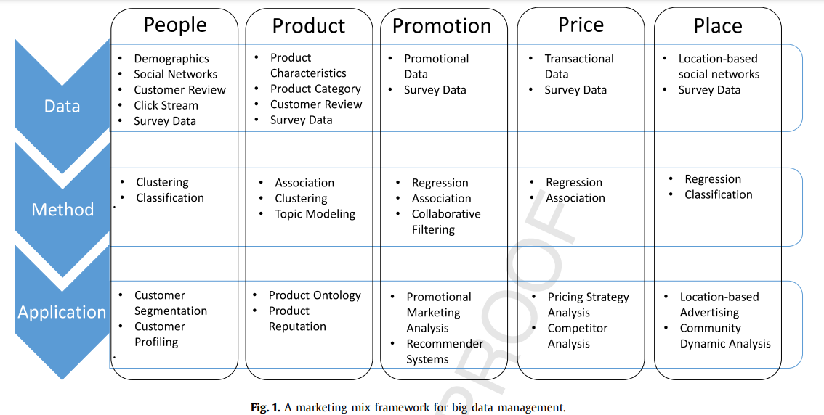

LIbraries to use :  
 The following libraries will be tested.

* Hommmer
* [MaMiMo](https://github.com/Garve/mamimo)

Preprocessing Block- These types of preprocessing.